**SECTION – 0**

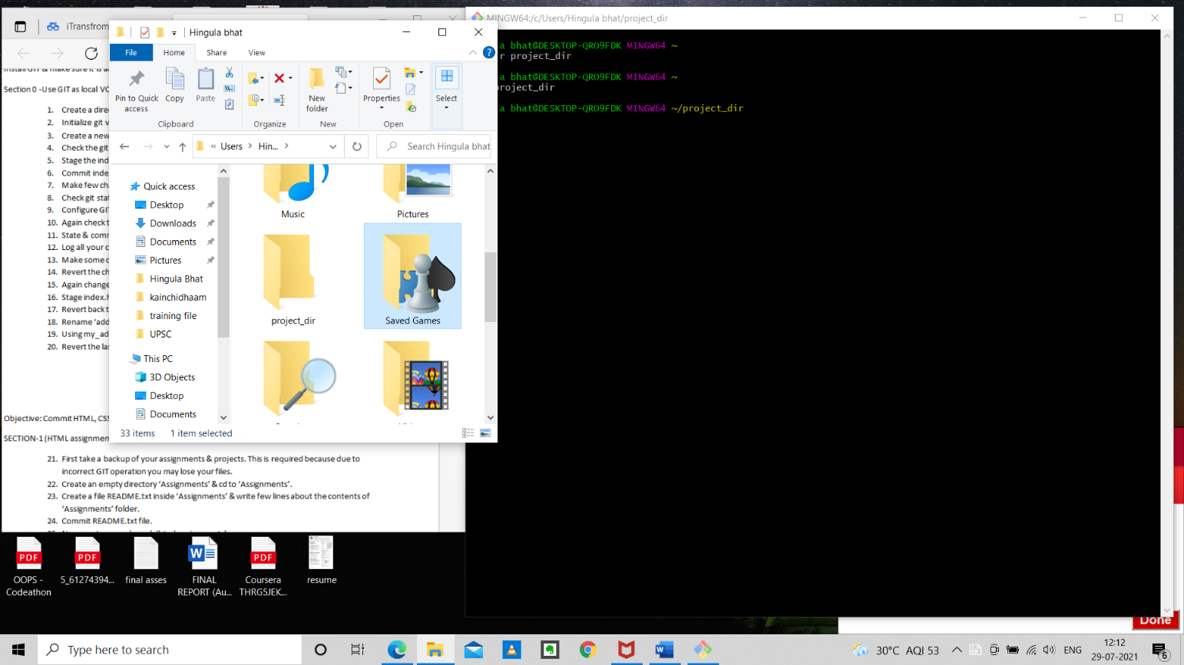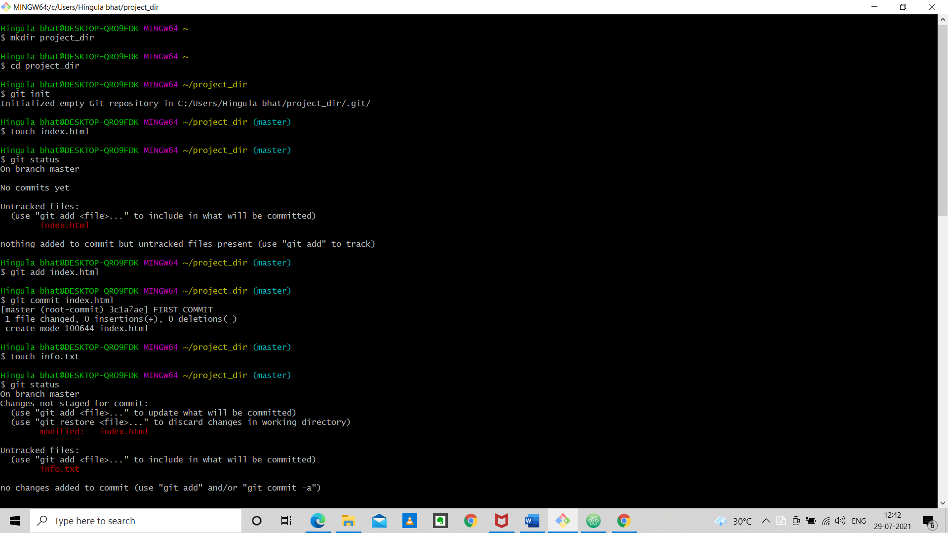

Local repo created

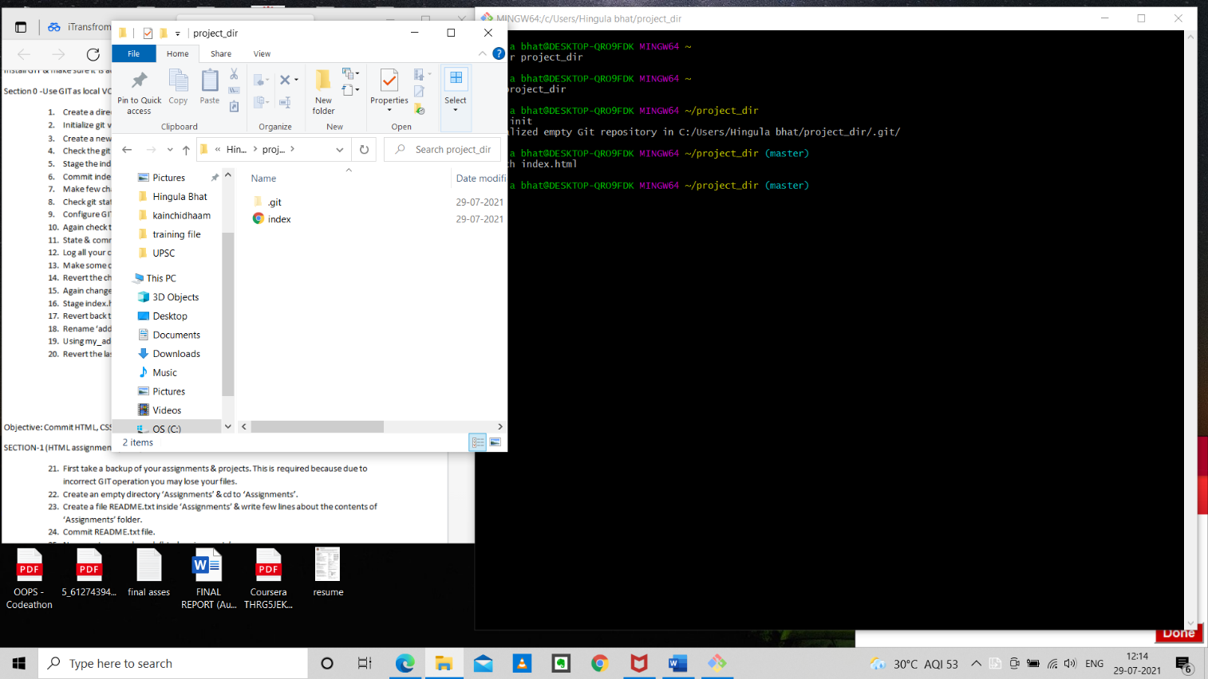

Index.html created

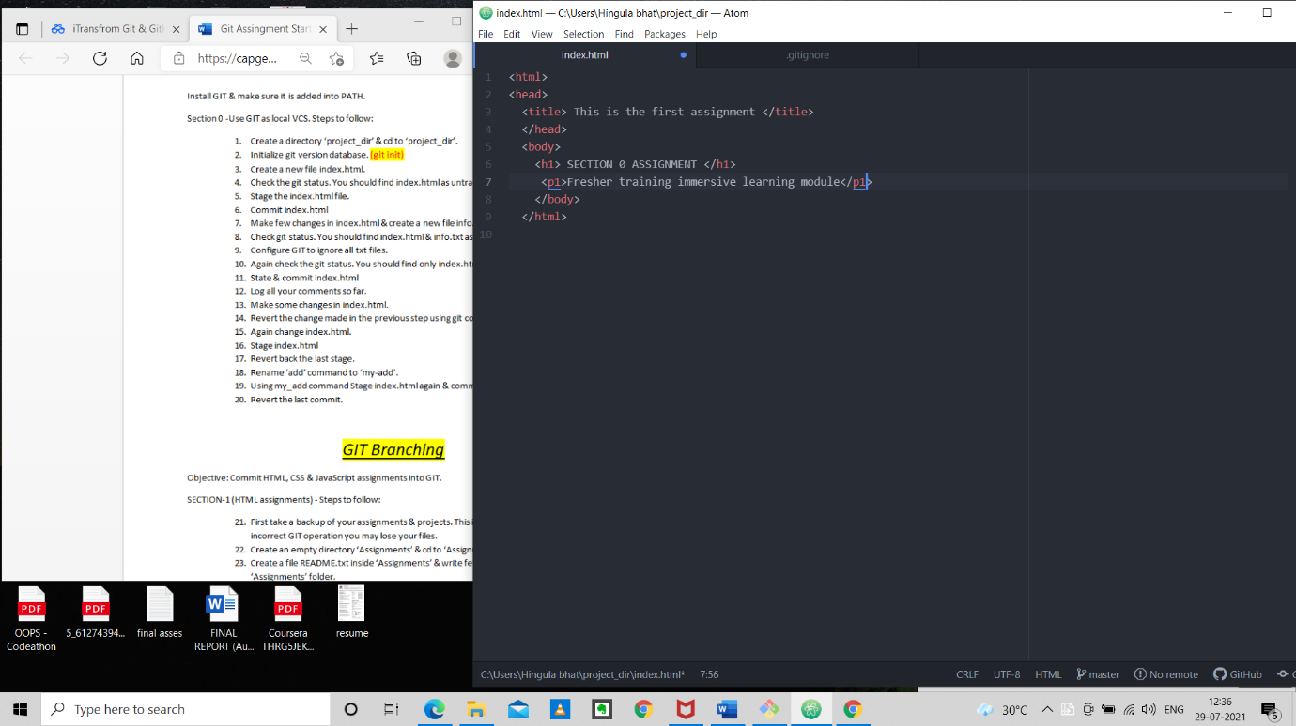

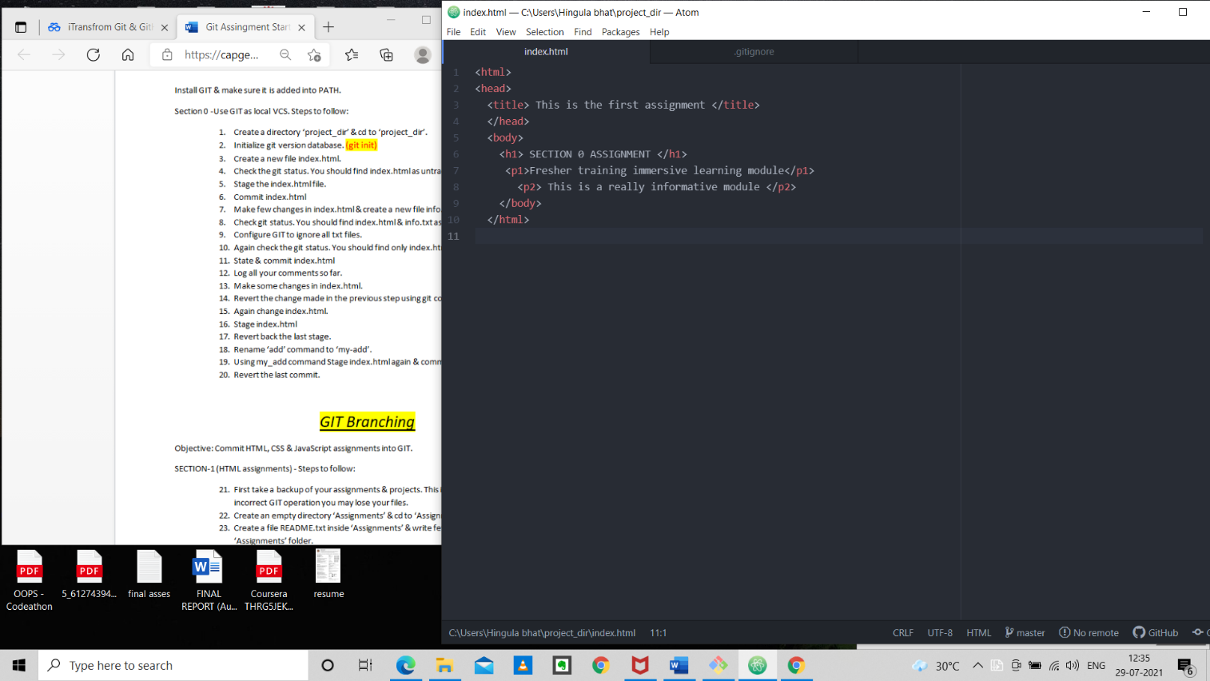

Changed html

Original html file

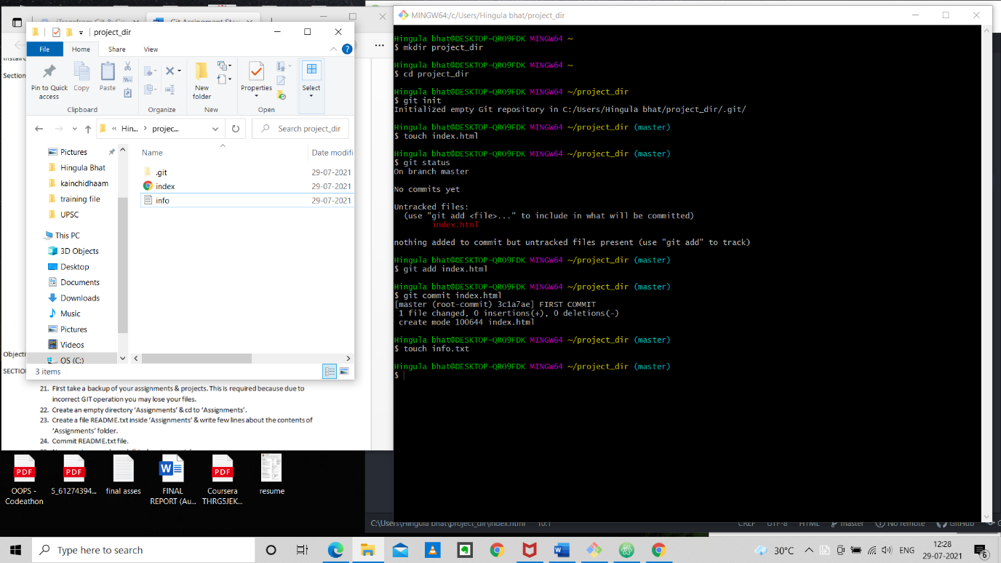

Info.txt created

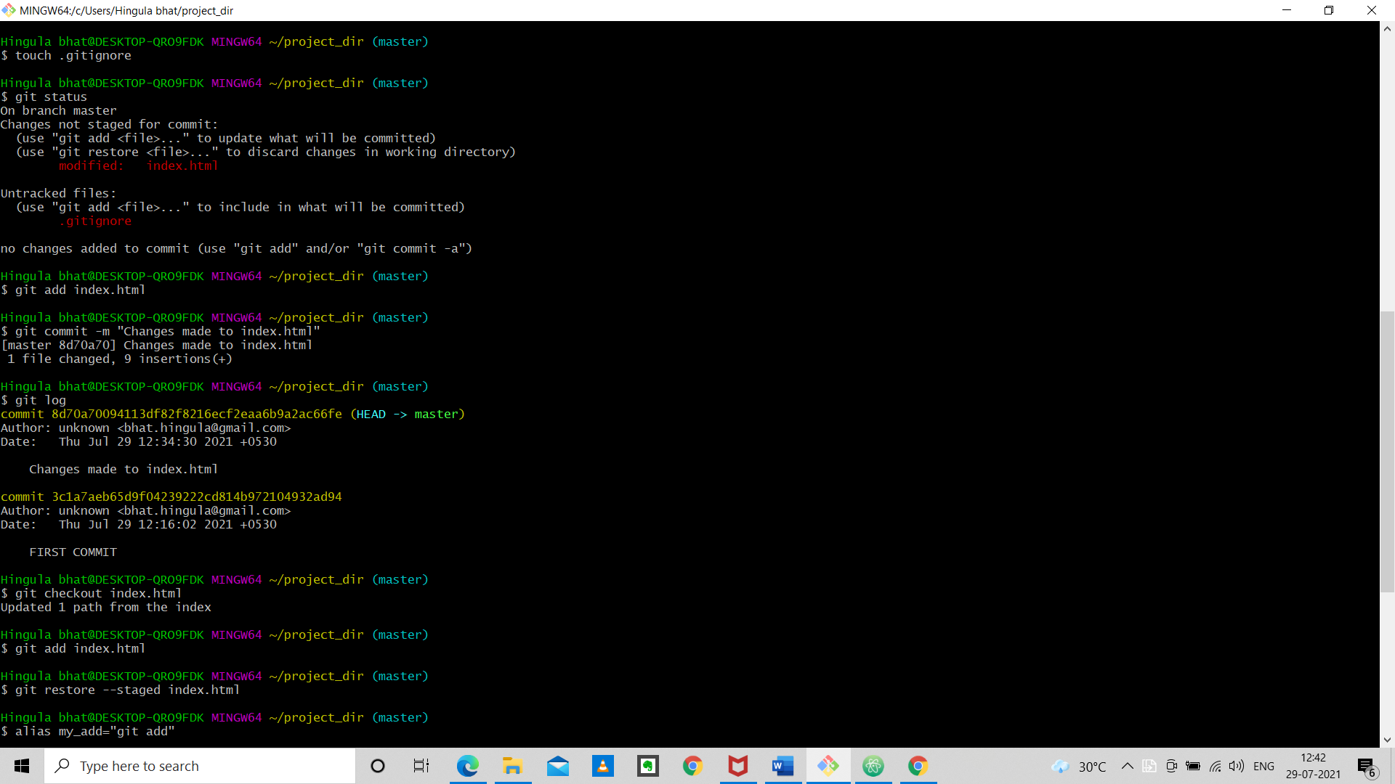Configuring Git to ignore txt files

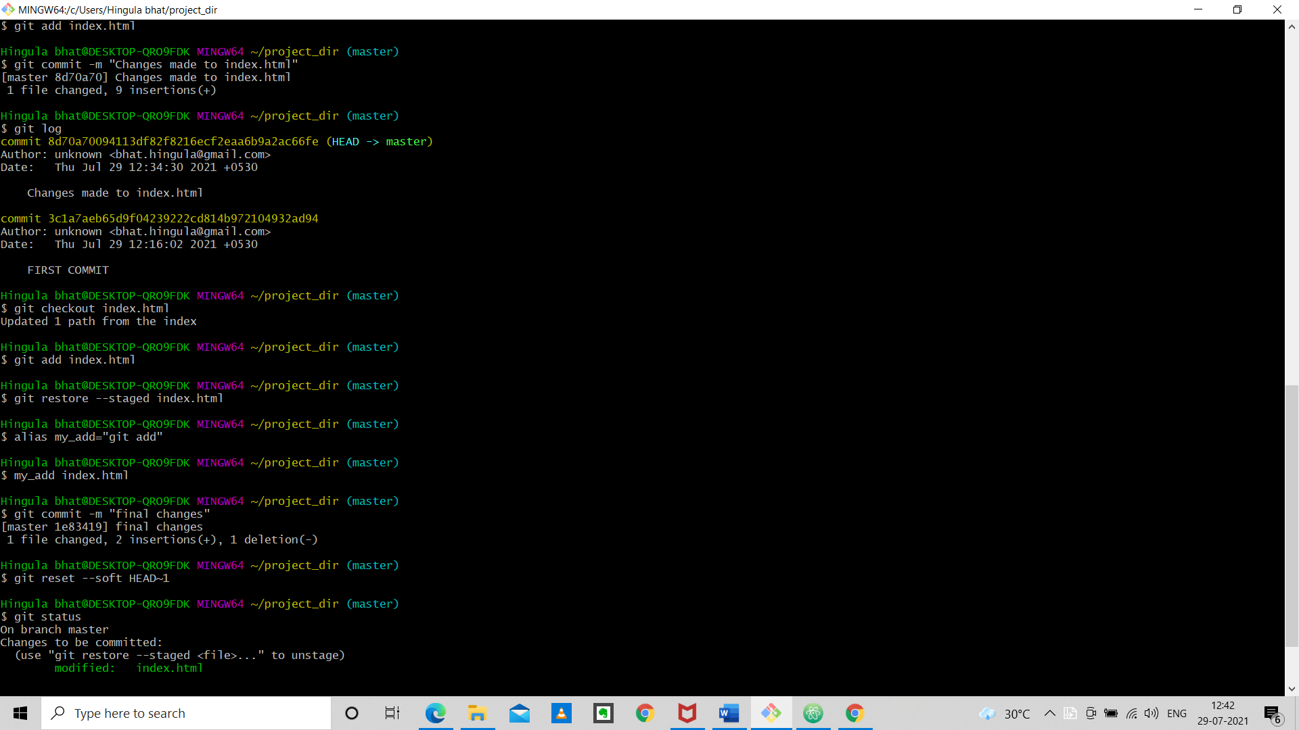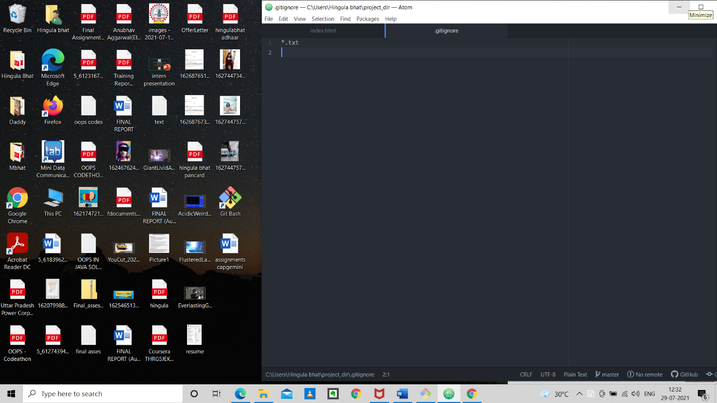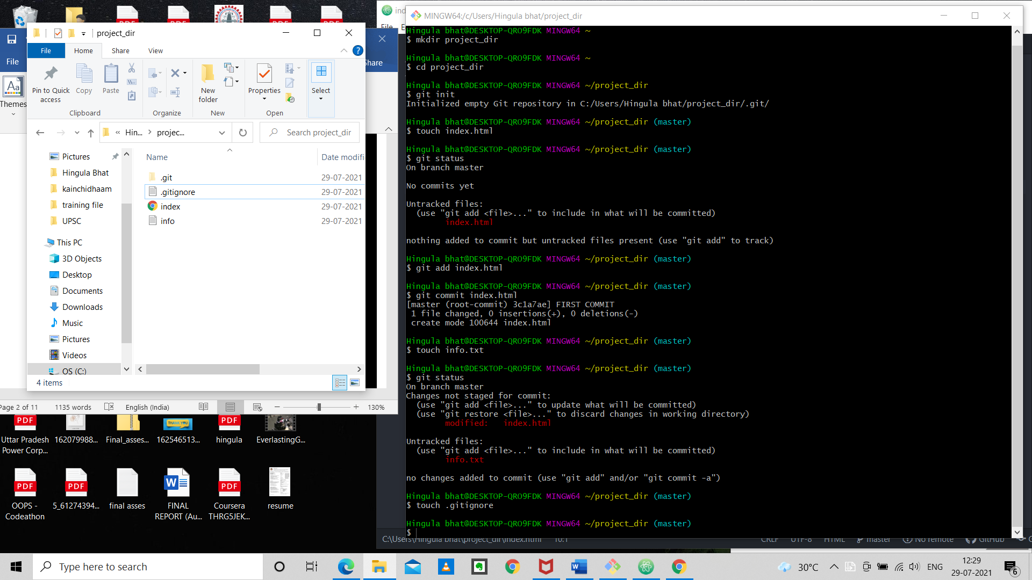

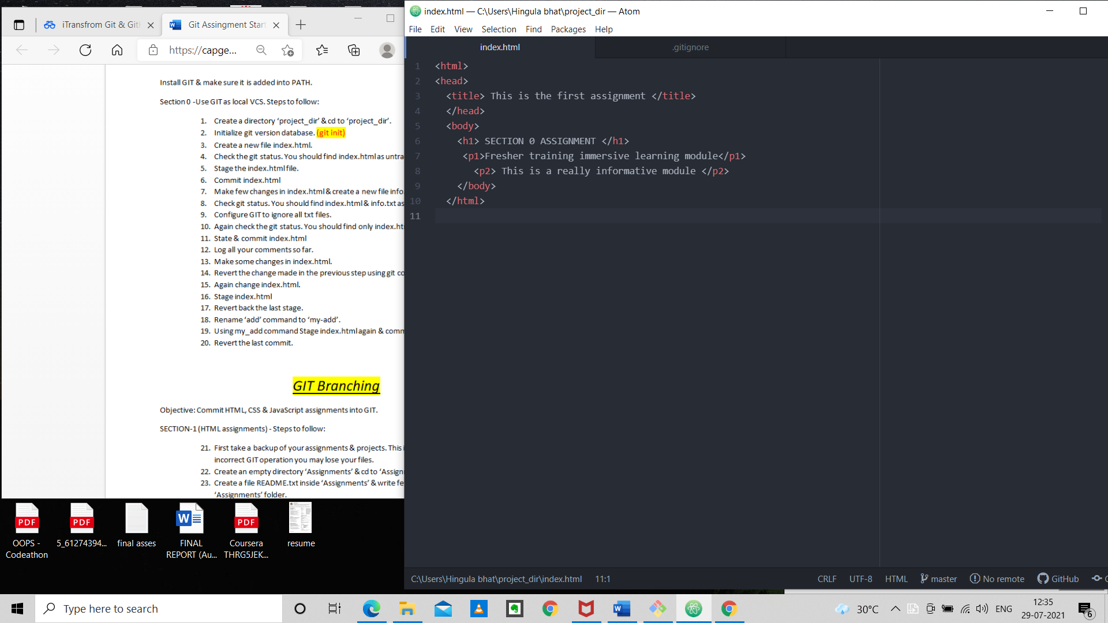changes made to index.html

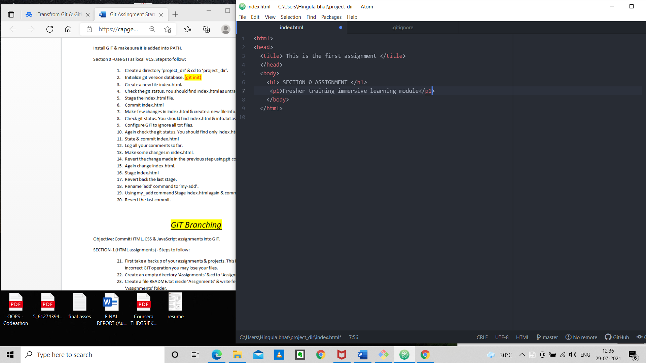

Reverted the changes

Hingula bhat@DESKTOP-QRO9FDK MINGW64 ~

$ mkdir project_dir

Hingula bhat@DESKTOP-QRO9FDK MINGW64 ~

$ cd project_dir

Hingula bhat@DESKTOP-QRO9FDK MINGW64 ~/project_dir

$ git init

Initialized empty Git repository in C:/Users/Hingula bhat/project_dir/.git/

Hingula bhat@DESKTOP-QRO9FDK MINGW64 ~/project_dir (master)

$ touch index.html

Hingula bhat@DESKTOP-QRO9FDK MINGW64 ~/project_dir (master)

$ git status

On branch master

No commits yet

Untracked files:

(use "git add <file>..." to include in what will be committed)

index.html

nothing added to commit but untracked files present (use "git add" to track)

Hingula bhat@DESKTOP-QRO9FDK MINGW64 ~/project_dir (master)

$ git add index.html

Hingula bhat@DESKTOP-QRO9FDK MINGW64 ~/project_dir (master)

$ git commit index.html

[master (root-commit) 3c1a7ae] FIRST COMMIT

1 file changed, 0 insertions(+), 0 deletions(-)

create mode 100644 index.html

Hingula bhat@DESKTOP-QRO9FDK MINGW64 ~/project_dir (master)

$ touch info.txt

Hingula bhat@DESKTOP-QRO9FDK MINGW64 ~/project_dir (master)

$ git status

On branch master

Changes not staged for commit:

(use "git add <file>..." to update what will be committed)

(use "git restore <file>..." to discard changes in working directory)

modified: index.html

Untracked files:

(use "git add <file>..." to include in what will be committed)

info.txt

no changes added to commit (use "git add" and/or "git commit -a")

Hingula bhat@DESKTOP-QRO9FDK MINGW64 ~/project_dir (master)

$ touch .gitignore

Hingula bhat@DESKTOP-QRO9FDK MINGW64 ~/project_dir (master)

$ git status

On branch master

Changes not staged for commit:

(use "git add <file>..." to update what will be committed)

(use "git restore <file>..." to discard changes in working directory)

modified: index.html

Untracked files:

(use "git add <file>..." to include in what will be committed)

.gitignore

no changes added to commit (use "git add" and/or "git commit -a")

Hingula bhat@DESKTOP-QRO9FDK MINGW64 ~/project_dir (master)

$ git add index.html

Hingula bhat@DESKTOP-QRO9FDK MINGW64 ~/project_dir (master)

$ git commit -m "Changes made to index.html"

[master 8d70a70] Changes made to index.html

1 file changed, 9 insertions(+)

Hingula bhat@DESKTOP-QRO9FDK MINGW64 ~/project_dir (master)

$ git log

commit 8d70a70094113df82f8216ecf2eaa6b9a2ac66fe (HEAD -> master)

Author: unknown <bhat.hingula@gmail.com>

Date: Thu Jul 29 12:34:30 2021 +0530

Changes made to index.html

commit 3c1a7aeb65d9f04239222cd814b972104932ad94

Author: unknown <bhat.hingula@gmail.com>

Date: Thu Jul 29 12:16:02 2021 +0530

FIRST COMMIT

Hingula bhat@DESKTOP-QRO9FDK MINGW64 ~/project_dir (master)

$ git checkout index.html

Updated 1 path from the index

Hingula bhat@DESKTOP-QRO9FDK MINGW64 ~/project_dir (master)

$ git add index.html

Hingula bhat@DESKTOP-QRO9FDK MINGW64 ~/project_dir (master)

$ git restore --staged index.html

Hingula bhat@DESKTOP-QRO9FDK MINGW64 ~/project_dir (master)

$ alias my_add="git add"

Hingula bhat@DESKTOP-QRO9FDK MINGW64 ~/project_dir (master)

$ my_add index.html

Hingula bhat@DESKTOP-QRO9FDK MINGW64 ~/project_dir (master)

$ git commit -m "final changes"

[master 1e83419] final changes

1 file changed, 2 insertions(+), 1 deletion(-)

Hingula bhat@DESKTOP-QRO9FDK MINGW64 ~/project_dir (master)

$ git reset --soft HEAD~1

Hingula bhat@DESKTOP-QRO9FDK MINGW64 ~/project_dir (master)

$ git status

On branch master

Changes to be committed:

(use "git restore --staged <file>..." to unstage)

modified: index.html

Hingula bhat@DESKTOP-QRO9FDK MINGW64 ~/project_dir (master)

$